The 15th International Conference on Electronic Properties of Two-Dimensional Systems (EP2DS-15) will be held in Nara, Japan, from July 14 (Mon.) through 18 (Fri.), 2003, under the sponsorship of.
International Union of Pure and Applied Physics
The Physical Society of Japan
The Japan Society of Applied Physics

Conference Scope
The EP2DS traditionally covers the fundamental physics of electronic and optical properties of systems based on semiconductor heterostructures and other low dimensional electronic systems.
The scope of the EP2DS-15 includes
・Quantum Hall effects and related phenomena
・Metal-insulator transition
・Electronic and optical properties
of quantum structures
・Transport in low dimensional systems
・Single electron phenomena
・Spin-related phenomena
・Quantum coherence and qubits
・Hybrid structures
・Organic conductors
・Carbon nanotubes
・Nanostructures
・Electrons on helium surface
・Novel probes and techniques

Proceedings
The Proceedings of the EP2DS-15 will be published as a special (but consecutively numbered) issue of the Journal Physica E Low-Dimensional Systems & Nano- structures.

Collaboration with MSS-11
The 11th International Conference on Modulated Semiconductor Structures (MSS-11) (Chairman: Prof. Y.Arakawa, Institute of Industrial Science, University of Tokyo) will be held at the same time and location. The participants of EP2DS-15 are entitled to attend sessions of MSS-11, and vice versa. There will be a few joint sessions on the topics of common interest. Most of the social activities (banquet, excursion, etc.) will be arranged jointly.

Venue
The conference site, Nara New Public Hall, is located in Nara Park, about 25 minutes on foot or about 10 minutes by bus from downtown Nara. Nara is one of the most historically important cities in Japan, located about 35 kilometers east of Osaka or south of Kyoto. It was the location of the capital of Japan in ancient times, 710-784A.D. Many important designated Cultural Assets and National Treasures can be found there, as well as temples, shrines, statues, carvings and paintings. In Nara Park, nature and history are beautifully preserved as they are, which include Todai-ji Temple, Koufuku-ji Temple, and Kasuga Grand Shrine. Nara park is also famous for its hundreds of tame deer that roam freely.

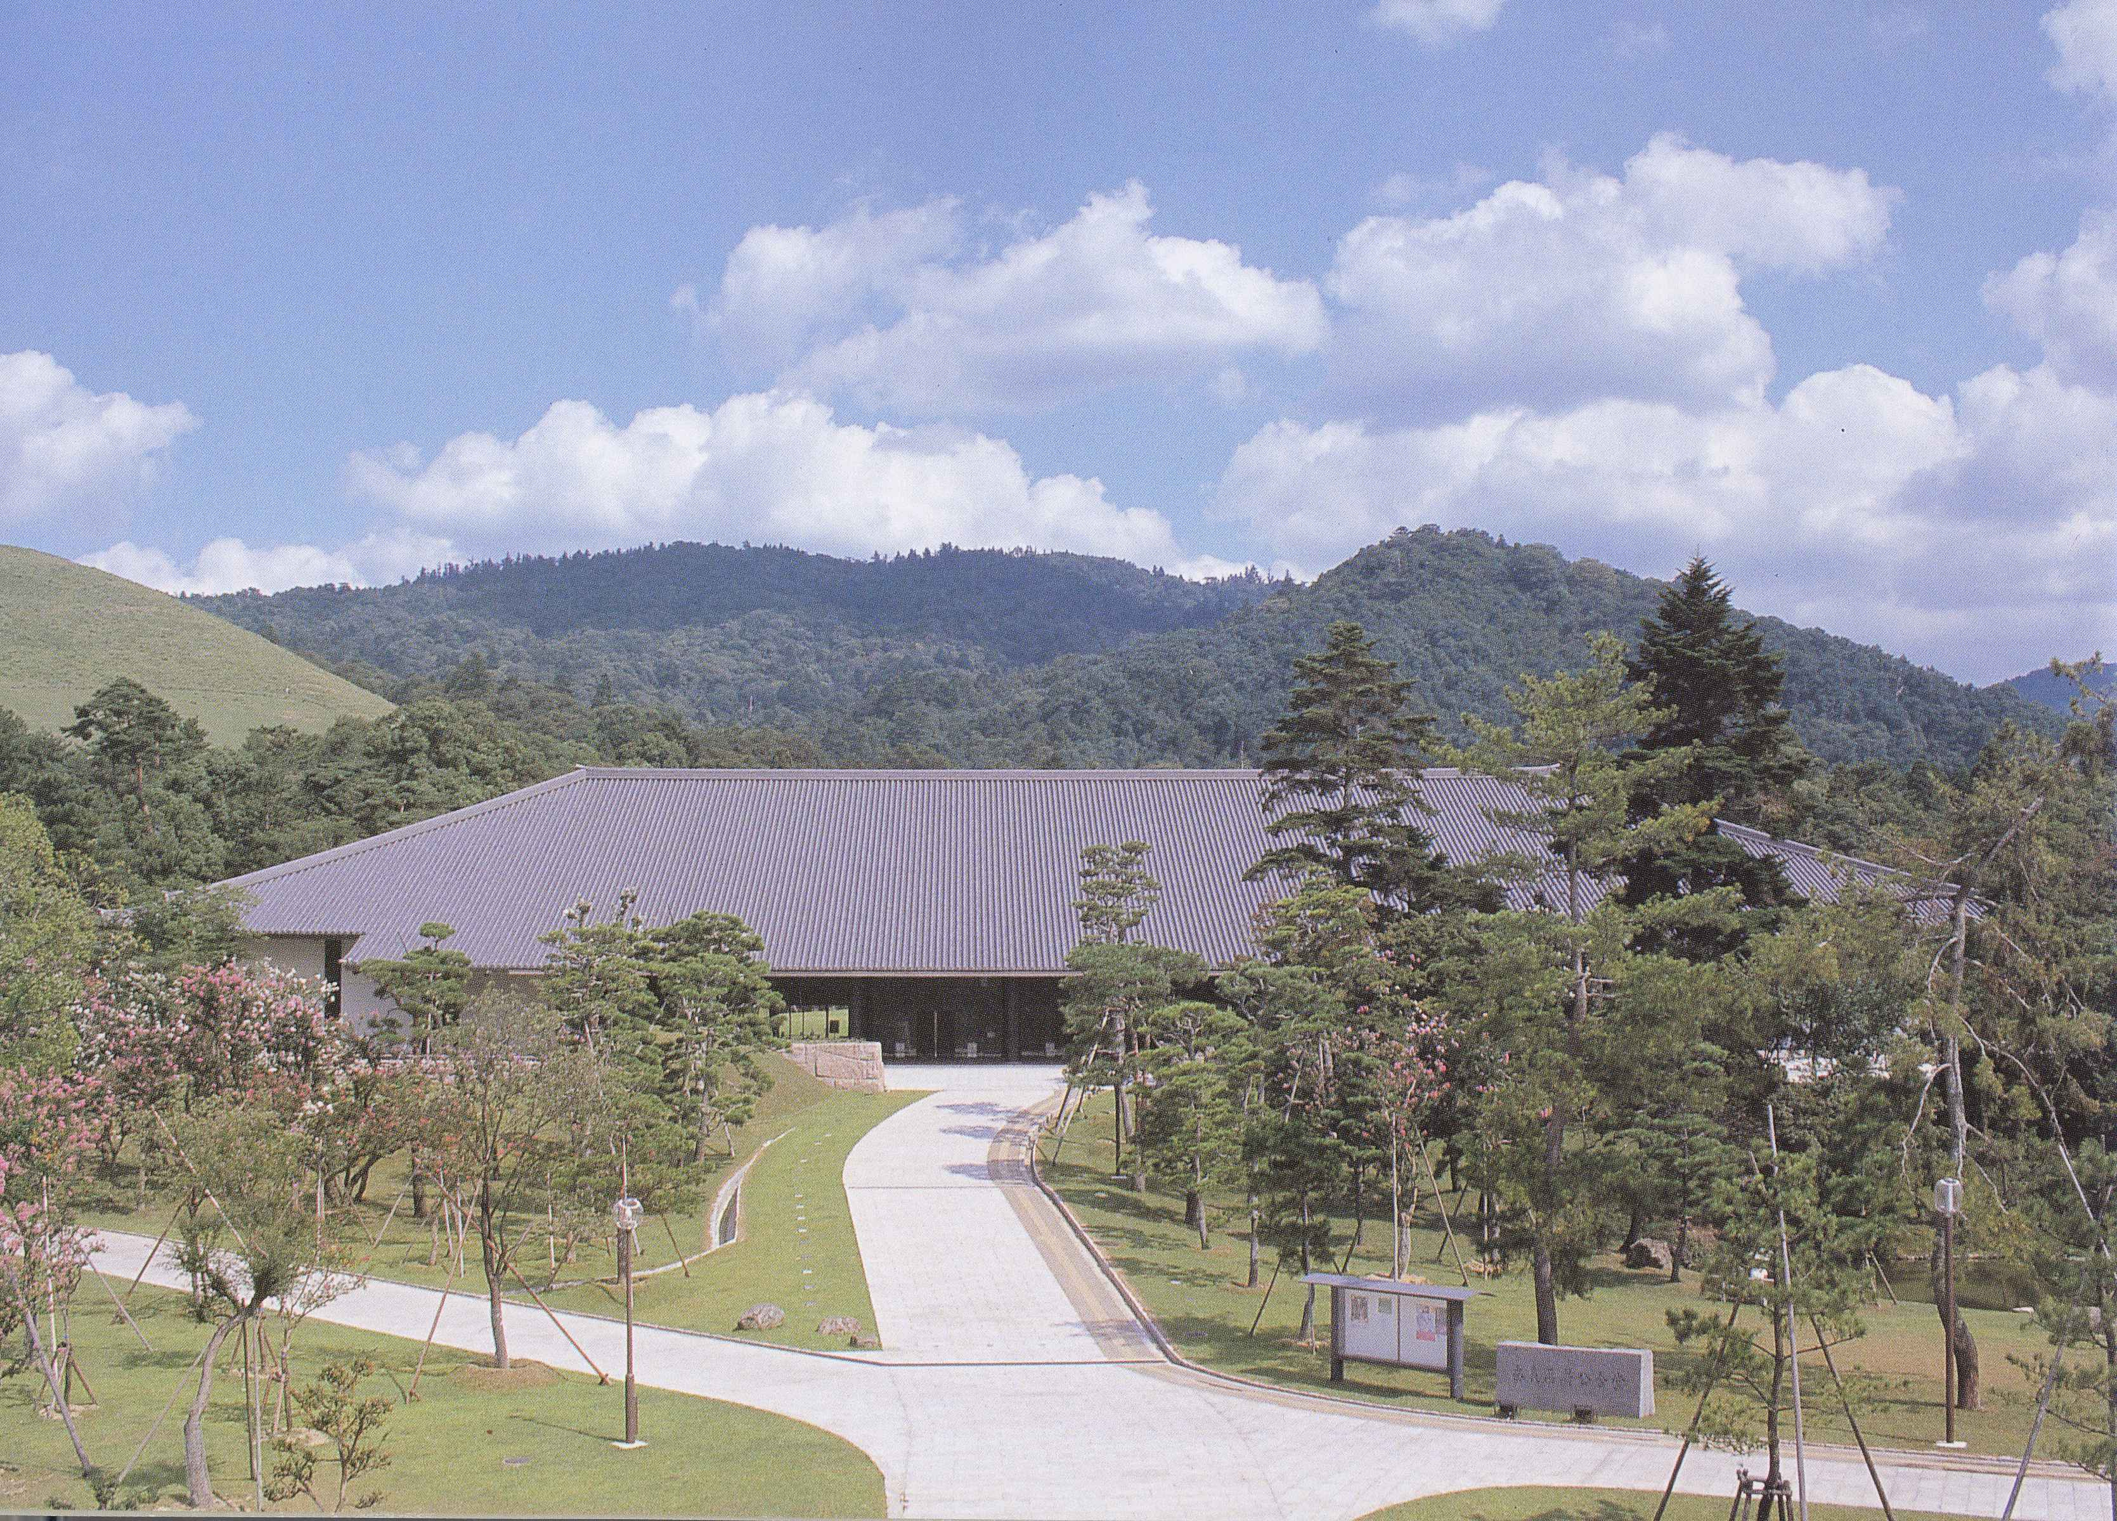
Nara New Public Hall (Shin-Kokaido)

More detailed information is available from the following websites;
・Japan National Tourist Organization
http://www.jnto.go.jp/eng/RTG/RI/kansai/nara/nara/nara.html
・Nara City Tourist Information Center
http://www1.sphere.ne.jp/naracity/j/e/e_n_hp.html

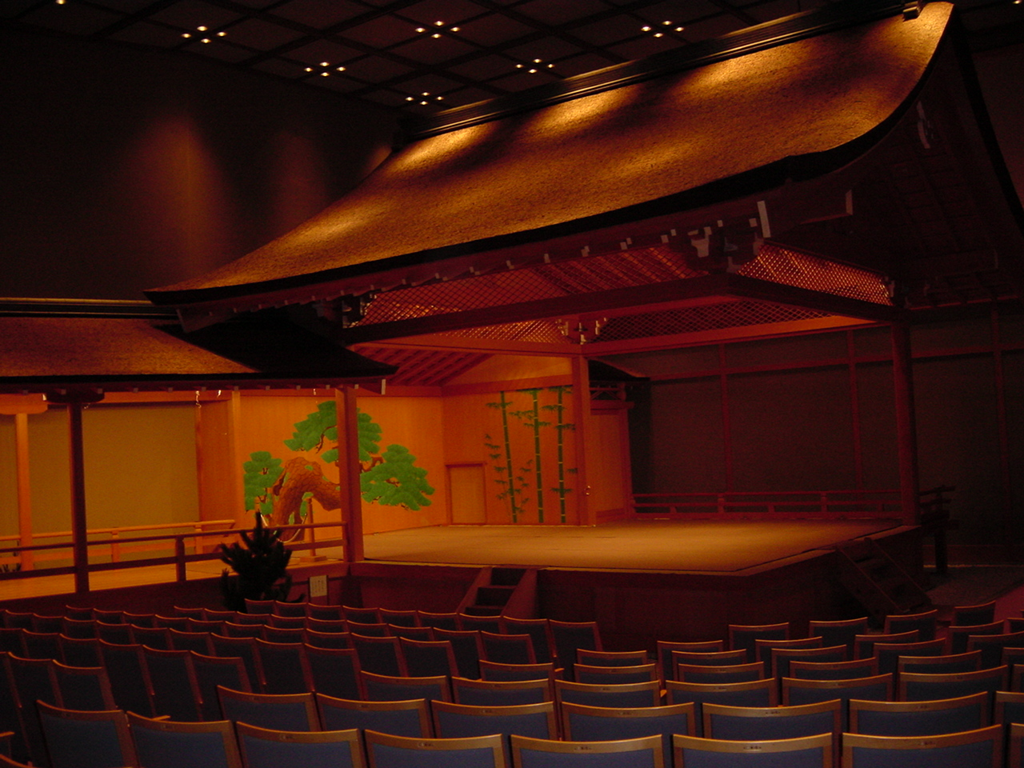Some of the oral presentations will be made in Noh Theater. (Noh is traditional theatrical performance art.)

Climate
The conference is held during the end of rainy season, beginning of humid Japanese summer. The average temperature is around 26℃ in the day and 22℃ at night. Be sure to bring an umbrella or rain wear.

Passport and Visa
All persons entering Japan must have a valid passport. In addition, persons coming from certain countries must have a visa issued by a Japanese consul in their country. For details, please inquire at your nearest Japanese Embassy or Consulate. The website of the Ministry of Foreign Affairs of Japan is;
http://www.mofa.go.jp/j_info/visit/visa/index.html
Organizing Committee
Y.Iye (ISSP, Univ. of Tokyo): Chair
S.Iwabuchi (Nara Woman’s Univ.)
S.Katsumoto (ISSP, Univ. of Tokyo)
K.Kono (Riken)
S.Tarucha (Univ. of Tokyo)
H.Takayanagi (NTT)
D.Yoshioka (Univ. of Tokyo): Program

International Program Committee
D.Yoshioka (Japan): Chair
M.I.Dykman (USA)
Y.Iye (Japan)
T.M.Klapwijk (The Netherland)
I.V.Kukushikin (Russia)
A.H.MacDonald (USA)
R.J.Nicholas (UK)
C.Tejedor (Spain)
K.von Klitzing (Germany)

International Advisory Committee
S.J.Allen (USA) T.Ando (Japan)
R.Clark (Australia) T.Dietl (Poland)
L.Eaves (UK) H.Fukuyama(Japan)
D.C.Glattli (France) B.I.Halperin (USA)
M.Heiblum (Israel) Y.Imry (Israel)
S.Kawaji (Japan) S.Komiyama (Japan)
J.P.Kotthaus (Germany) J.J.Lin (Taiwan, China)
Y.E.Lozovik (Russia) E.Molinari (Italy)
F.Peeters (Belgium) A.Pinczuk (USA)
P.Streda (Czech) H.L.Stormer (USA)
N.Studart (Brazil) S.-R.E.Yang (Korea)

Important Dates
December, 2002 Second Circular and Call for Papers
March 1st, 2003 Deadline for Abstract Submission
May 1st Notification of Acceptance
June 6th Deadline for Early Registration
June 6th Deadline for
Manuscript Submission
June 6th Accommodation&Tour Reservation

Website
Information on the EP2DS-15 will be posted on the following website
http://www.issp.u-tokyo.ac.jp/ep2ds-15/

The website of the MSS-11 is
http://www.mss.iis.u-tokyo.ac.jp

Correspondences

EP2DS-15 Secretariat (Prof. Yasuhiro Iye)
Institute for Solid State Physics,
University of Tokyo
5-1-5, Kashiwanoha, Kashiwa,Chiba 277-8581 Japan
fax and telephone: +81-4-7136-3300
e-mail: ep2ds-15@issp.u-tokyo.ac.jp

First Announcement

The 15th International Conference
on
Electronic Properties of
Two-Dimensional Systems

EP2DS-15

14(Mon.)-18(Fri.) July 2003
Nara, Japan

