Thermal changes of structures and properties of π-backdonating
metal complexes (in 2011)
Takashiro Akitsu*

*Department of Chemistry, Faculty of Science, Tokyo University of Science
During a course work on thermally-accessible structural changes of crystals of metal complexes, we have observed some interesting results associated with structural flexibility as follows [1-3 and references therein and some other preparing papers]: H/D isotope effect on negative thermal expansion (hydrogen bonds) of magnetic Nd(DMF)₄(H₂O)₃Fe(CN)₆•H₂O complexes; thermally-accessible structural changes of Jahn-Teller coordination bonds in cyanide-bridged coordination polymers containing Cu(II) ion; separated observation of temperature dependence of crystal lattice and Jahn-Teller coordination bonds of zigzag 1D coordination polymers containing Cu(II) ion; polymorphism of diastereomers of cyanide-bridged coordination polymers containing chiral Cu(II) complex by H/D isotopes; reasonable preparation methods of magnetic CuMn oxides from chiral Cu(II) complexes and Mn(III)/Mn(IV) single molecule magnets. Additionally, cyanide (CN⁻) is one of the most typical ligands for forming π-backdonation.
Herein, we report on preparation, crystal structures, and soft X-ray absorption spectra (XAS) of a chiral mononuclear Cu(II) complex, [CuL₂](C(CN)₃)₂ (L = (1R, 2R)-diaminocyclohexane). Interestingly, this new compound exhibited novel polymorphism and different features of phase transition.
Figure 1 shows the orthorhombic (P2₁2₁2) form of CuL₂](C(CN)₃)_{2.} At 296 K, crystal cell is a = 15.7562(10) Å, b = 16.0252(11) Å, c = 9.5417(6) Å, V = 2409.2(3) Å³. The ratios of thermal expansion between 100 K and 296 K are +0.77 % for a-axis, +0.22 % for b-axis, and +1.16 % for c-axis. Structural phase transition was observed around 230 K. On the other hand, the monoclinic (P2₁) form of form of CuL₂](C(CN)₃)₂ did not exhibit structural phase transition, in other words, merely positive thermal expansion was observed. At 296 K, crystal cell is a = 15.7554(8) Å, b = 16.0203(8) Å, c = 9.5416(5) Å, β = 89.951(2) ˚, V = 2408.4(2) Å³. The ratios of thermal expansion between 100 K and 296 K are +0.77 % for a-axis, +0.22 % for b-axis, and +1.16 % for c-axis. Both forms could be distinguished according to XRD patterns and its systematic absence of reflections.
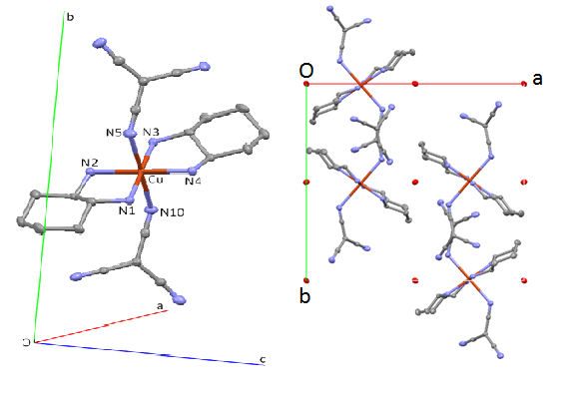
Figure 1. Molecular (left) and crystal (right) structures of the orthorhombic form of [CuL₂](C(CN)₃)₂.
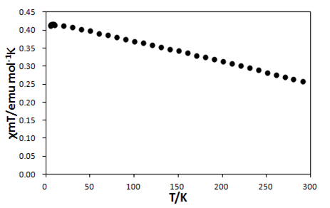
Figure 2. The χ_{M}T vs T plot of [CuL₂](C(CN)₃)₂.

Figure 2 depicts temperature dependence of magnetic properties of the form without structural phase transition. No leaps of data for an isolated s = 1/2 system of distorted octahedral coordination environment could be observed for a mononuclear Cu(II) complex.
The Cu2p_{3/2} and Cu2p_{1/2} peaks of XAS were measured at KEK PF BL-19B (2010G510) under variable temperature. Figure 3 exhibits temperature dependence of soft X-ray absorption spectra (XAS) for [CuL₂](C(CN)₃)₂ measured at various temperature. At high temperature, the Cu2p_{1/2} and Cu2p_{3/2} peaks appeared at about 952 and 932 eV, respectively. On cooling, the intensity of the two peaks decreased clearly, though this compound was quite stable and Cu(II) ion was contained surely in [CuL₂](C(CN)₃)_{2.}

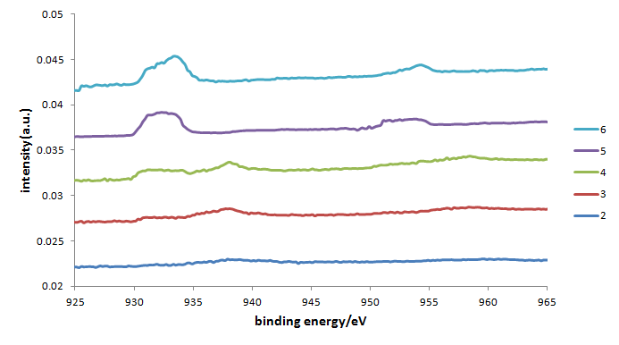
Figure 3. The XAS of (right) Cu2p_{1/2} and (left) Cu2p_{3/2} peaks for [CuL₂](C(CN)₃)₂ and its temperature dependence 6 (room temperature) > 5 > 4 > 3 > 2 (low temperature).

In summary, we have prepared we have prepared a new chiral Cu(II) complex, [CuL₂](C(CN)₃)₂, which exhibit novel polymorphism showing or not showing structural phase transition. Whether disagreement between temperature dependence of magnetic data (continuous changes) and XAS data (different features at high and low temperature region) is ascribed to the polymorphism or not are elucidated at present.

References

[1] Activity Report of Synchrotron Radiation Laboratory 2008.
[2] Activity Report of Synchrotron Radiation Laboratory 2009.
[3] Activity Report of Synchrotron Radiation Laboratory 2010.

