An Investigation of Electronic Structure of Novel Electrode Materials for Li-ion Batteries by Soft X-ray Absorption and Emission Spectroscopy
Daisuke Asakura, Masashi Okubo, Yoshifumi Mizuno, Yusuke Nanba, Haoshen Zhou
Energy Technology Research Institute, National Institute of Advanced Industrial Science and Technology
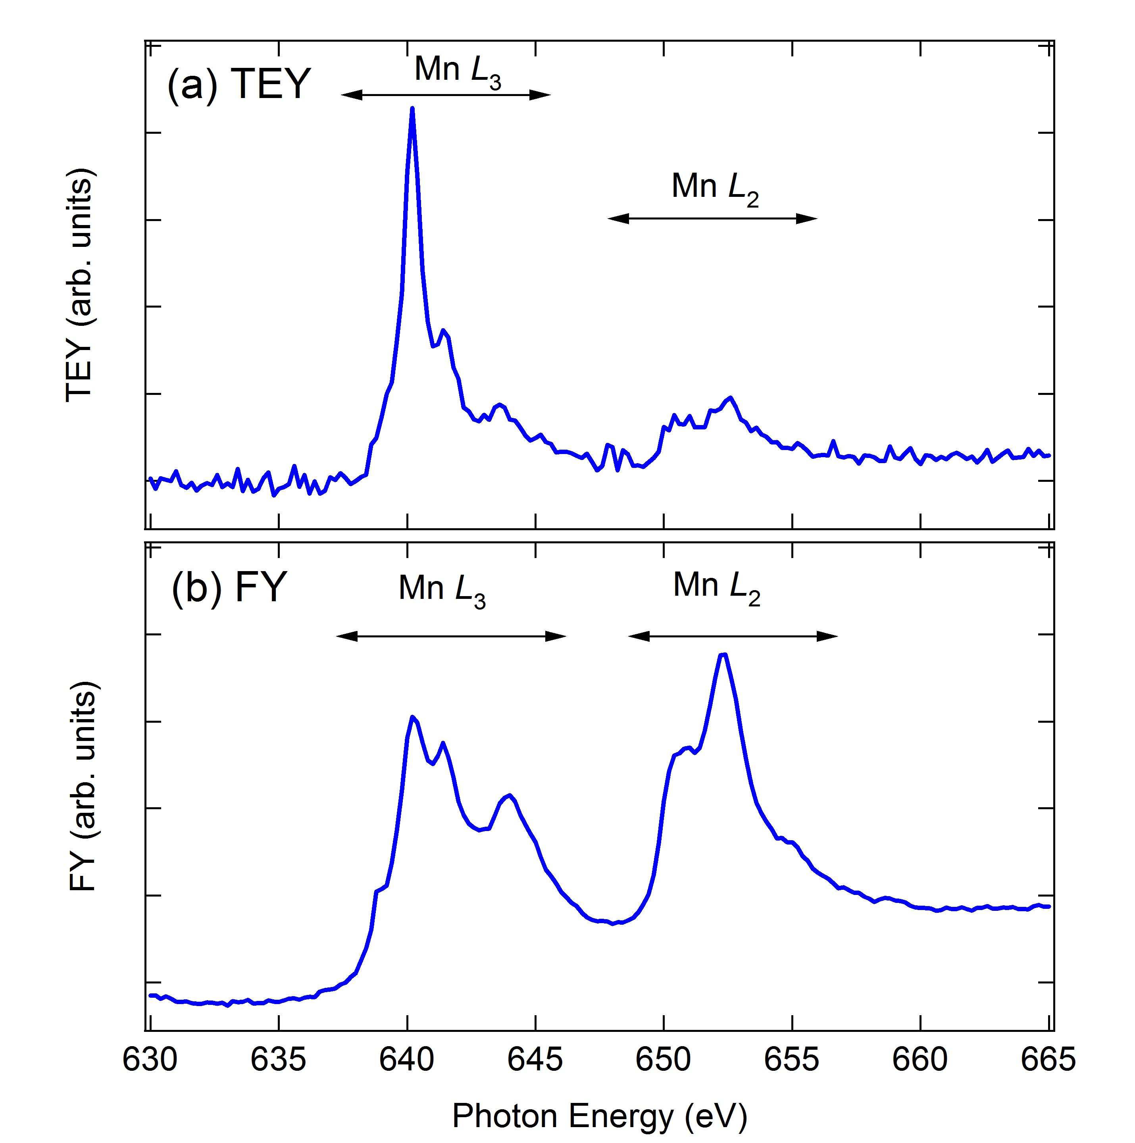
We have been focusing Prussian blue analogue (PBA) as a candidate of cathode material for Li-ion batteries [1]. PBAs generally have a perovskite structure with cyanide bridges: A_{x}M[M’(CN)₆]_{y}·nH₂O (A: alkali metal; M and M’: transition metals (TMs)). Li ions can be inserted to/extracted from the A site electrochemically. Recently, we found that K_{1.72}Mn[Mn(CN)₆]_{0.93}·0.65H₂O (MnMn-PBA) could store 1.9Li ions per formula after full K-ion extraction [2]. This corresponds to a charge-discharge capacity of 200 mAh/g which exceeds capacities for conventional cathode materials (e.g., 150 mAh/g for LiCoO₂). The result suggests that all the TMs, i.e., all Mn, could be redox active as Mn²⁺⇔Mn³⁺ in contrast to typical PBAs such as K_{0.1}Mn[Fe(CN)₆]_{0.7}·4.2H₂O (60 mAh/g, only the Fe site is redox active [1,3]). On the other hand, Her et al. reported that MnMn-PBA showed ferrimagnetism and the spin state was different between the C-coordinating Mn (Mn_{C}) and N-coordinating Mn (Mn_{N}) [4]. They concluded that Mn_{C} with a strong crystal field should be of Mn²⁺ low-spin (LS) state while Mn_{N} could be of Mn²⁺ high-spin (HS) state. Thus, the redox reaction of Mn²⁺⇔Mn³⁺ in during charge/discharge would be complex.
To fully understand the redox reaction, for a start, investigation of the Mn 3d electronic structure distinguishing between the Mn spin states in MnMn-PBA is highly important. Soft x-ray absorption (XAS) and soft x-ray emission spectroscopy (XES) were employed in this study. XES could be beneficial to distinguish between the Mn spin states when the excitation energy is appropriately chosen.
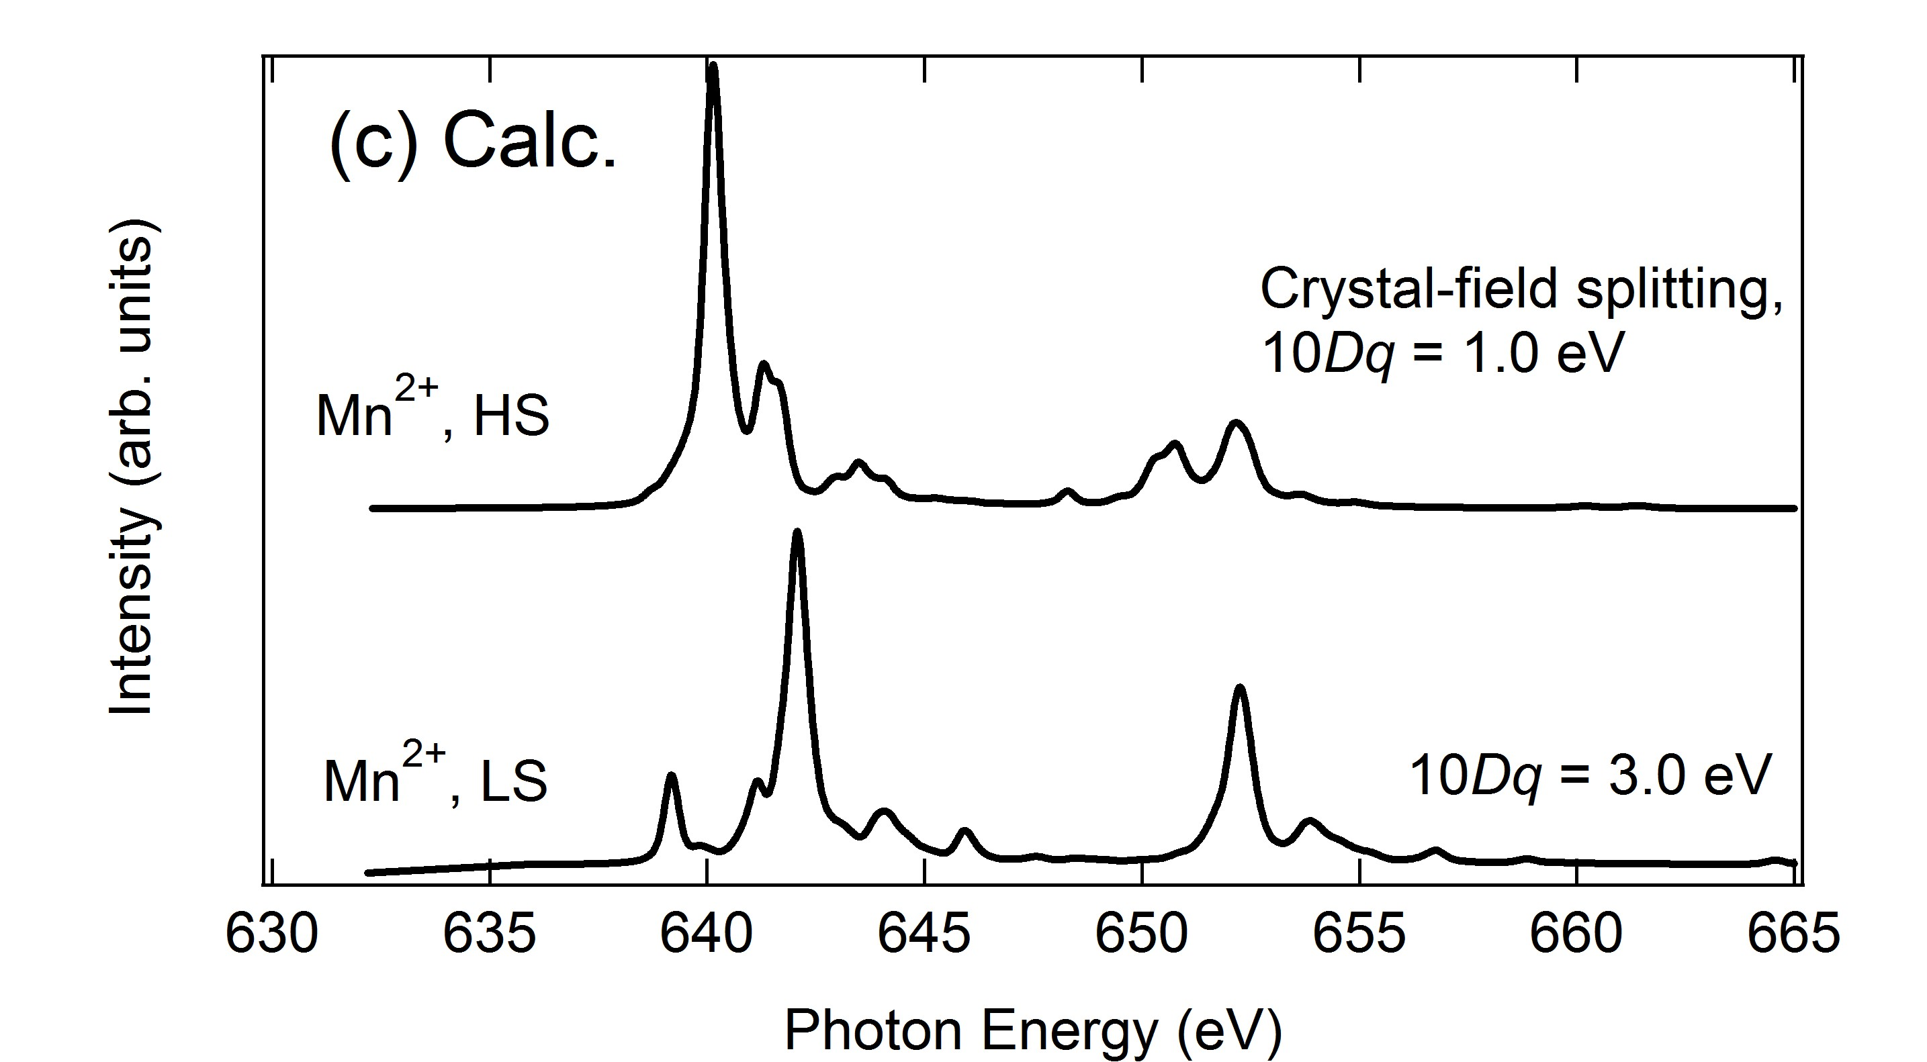
MnMn-PBA powder was fabricated by a precipitation method. XAS and XES measurements were performed at BL07LSU in SPring-8. The total electron-yield (TEY) and fluorescence-yield (FY) modes were employed for the Mn L_{2,3}-edge XAS. The XES measurements were carried out using ultra-high-resolution XES spectrometer, HORNET. The XAS and XES experiments were performed at room temperature. To analyse the spectra the configuration -interaction full-multiplet calculations were performed.
Fig. 1: Mn L_{2,3}-edge (a) TEY and (b) FY XAS for MnMn-PBA. (c) Calculated results for Mn²⁺ HS and LS states.
Figure 1(a) shows the Mn L_{2,3}-edge TEY XAS consisting of three peaks in the L₃ region and two peaks in the L₂ one. This multiplet structure is attributed to only the Mn²⁺ HS state (Fig. 1(c)) and any fingerprints of Mn²⁺
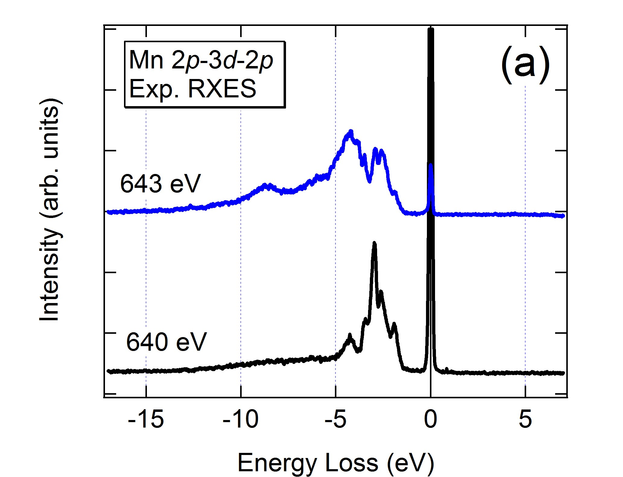
LS state could not be observed. In general, the probing depth of TEY mode is less than 5 nm. Thus, the Mn²⁺ LS state should not exist in the surface region.
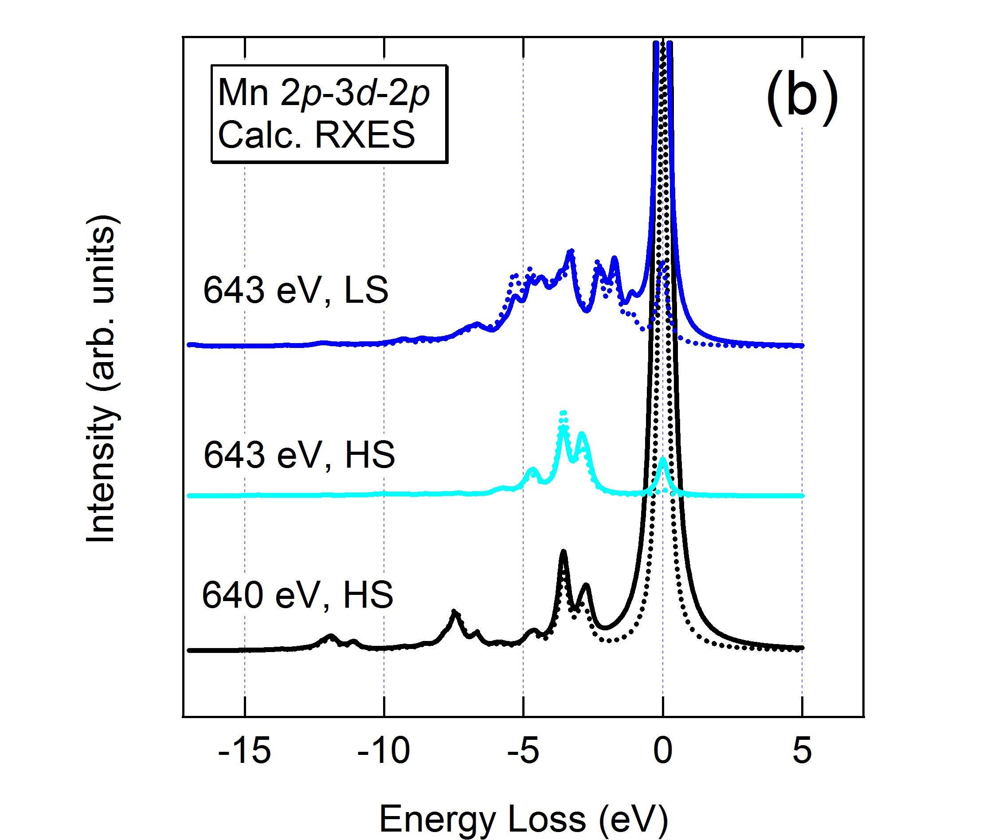
As Fig. 1(b) shows, the Mn L_{2,3}-edge FY XAS is quite different from the TEY XAS while the peak positions are almost similar. The enhancements of the peaks at 644, 652.5 eV should be intrinsic although the saturation effect in the FY mode distorts the spectrum. The calculated result for Mn²⁺ LS state indicates the peak at 652.4 eV and the shoulder at 655 eV could be of the Mn²⁺ LS state. On the other hand, the peak at 644 eV in the experimental FY spectrum was not reproduced. In general, the distortion due to the saturation effect increases in going to higher energy region. Most likely, the calculated Mn²⁺-LS main peak at 642 eV in the L₃ region would be hidden in the broadened base line around 642-645 eV.
The shoulders at 639 eV in the FY result could be of the unoccupied t_{2g} orbital for the Mn²⁺ LS state. In the calculated spectrum the energy separation between that peak and the main peak is 3 eV, which is equal to the crystal-field splitting 10Dq. Thus, the peaks at 639 eV and 642 eV can be attributed to t_{2g} and e_{g} orbitals, respectively. The similar situation was observed in Fe L₃-edge XAS for Fe³⁺ LS state [3], i.e., 3d⁵ LS state with a hole in the t_{2g} orbital.
Fig. 2: (a) Mn 2p RXES and (b) the calculated results with polarization dependence. In (b), the solid and dotted lines mean the in-plane and out-of-plane geometries, respectively.
To further clarify the Mn²⁺ LS state, high energy resolution Mn 2p resonant XES (RXES) was carried out. The excitation energies of 640 and 643 eV were chosen, because the Mn²⁺ HS character could be dominant at 640 eV and the Mn²⁺ LS one would be included around 643 eV as discussed above. Figure 2(a) displays the RXES. As for the 640-eV spectrum, the d-d excitation from -2 to -5 eV is similar to that for MnO [5], suggesting the Mn²⁺ HS state is dominant at 640 eV. In fact, the calculation for Mn²⁺ HS well reproduced the experimental spectrum (Fig. 2(b)). For the 643-eV spectrum, the d-d excitation, particularly the enhanced peak at -4 eV is attributed to the Mn²⁺ LS state. This peak could not be observed in MnO [5].
In summary, we succeeded in distinguishing between the spin states in MnMn-PBA by combined use of TEY XAS, FY XAS and XES. In future, the redox reaction of MnMn-PBA during Li-ion insertion/extraction will be investigated.

References

[1] M Okubo et al., J. Phys. Chem. Lett. 1, 2063 (2010).
[2] D. Asakura et al., J. Phys. Chem. C 116, 8364 (2012).
[3] D. Asakura et al., Phys. Rev. B 84, 045117 (2011).
[4] J.-H. Her et al., Inorg. Chem. 49, 1524 (2010).
[5] G. Ghiringhelli et al., Phys. Rev. B 73, 035111 (2006).

