Synchrotron Radiation Laboratory

The Synchrotron Radiation Laboratory (SRL) was established in 1975 as a research division dedicated to solid state physics using synchrotron radiation. Currently, SRL is composed of three research sites, the Sendai office, the Harima office and the E-building of the Institute for Solid State Physics.

Synchrotron soft X-ray experimental stations at Sendai office and Harima office
In 2009 SRL established the Harima branch laboratory in SPring-8 and operated a high brilliant and polarization-controlled 25-m long soft X-ray undulator beamline, BL07LSU until August 2022 in collaboration with Synchrotron Radiation Research Organization (SRRO) of the University of Tokyo. The management of the beamline was transferred to the RIKEN SPring-8 Center in September 2022. In November 2022, the Sendai office was formed on the Aobayama campus of Tohoku University under the auspices of a new SRRO launched in April 2022 and includes six departments of the University of Tokyo. At the end of FY2022, three endstations, ambient pressure X-ray photoemission (APXPS) (Fig. 1a), nanoESCA (Fig. 1c), and high resolution soft X-ray emission spectroscopy (HORNET) (Fig. 1d) stations were relocated to the new 3GeV synchrotron facility NanoTerasu in Sendai, which started commissioning of the storage ring in early 2023. On March 25, 2022, the Sendai office relocated to the SRIS (International Center for Synchrotron Radiation Innovation Smart) building of Tohoku University which is one of the closest buildings to NanoTerasu. The three endstations, APXPS, nanoESCA and HORNET stations resumed commissioning in the summer of 2023 and were realigned to the beamlines BL07U (nanoESCA and HORNET) and BL08U (APXPS) by the end of FY 2023. During commissioning, the APXPS system achieved 10-100 Torr for XPS measurement; the 3DnanoESCA station obtained a spatial resolution of roughly 100-200 nm; and the HORNET station provided spectra with the energy resolution around 500 meV at 500 eV. All of achievements in NanoTerasu are still considerably below the standards established in SPring-8; however, they will recover and even exceed the criteria once the beamlines are aligned after official operation begins in April, 2024.

The Harima office at SPring-8 continues in 2023 and the soft X-ray imaging (ptychography) (Fig. 1b) station is being developed in collaboration with the RIKEN SPring-8 Center. The novel soft X-ray ptychography system, which uses a total-reflection Wolter mirror, has a resolution of approximately 50 nm and its long working distance allows for stereo imaging with a high rotation angle.

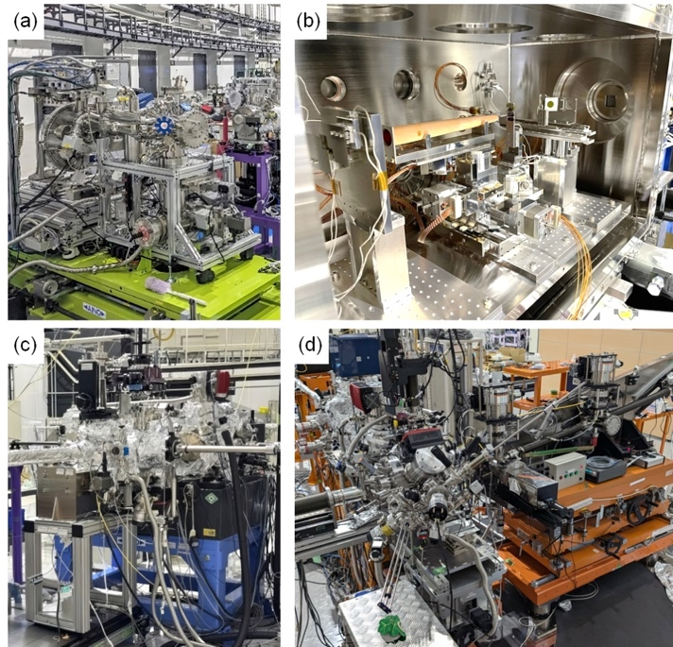

Fig. 1. Soft X-ray advanced experimental stations (a) Ambient pressure photoemission (APXPS) (b) Soft X-ray imaging (c) 3DnanoESCA (d) Soft X-ray emission (HORNET). APXPS, 3DnanoESCA and HORNET stations were transferred to the new 3GeV synchrotron facility NanoTerasu at the end of FY2022 and installed in BL07U (3DnanoESCA, HORNET) and BL08U (APXPS) at the end of FY2023.

High-resolution Laser SARPES and ARTOF system at E-building
High-resolution Laser Spin- and Angle-Resolved Photoemission Spectroscopy (SARPES) is a powerful technique to investigate the spin-dependent electronic states in solids. In FY2014, LASOR and SRL staffs constructed a new SARPES apparatus (Fig. 2a), which was designed to provide high-energy and -angular resolutions and high efficiency of spin detection using a laser light at E-building. The achieved energy resolution of 1.7 meV in SARPES spectra is the highest in the world at present. From FY2015, the new SARPES system has been opened the joint-research program. The Laser-SARPES system consists of an analysis chamber, a carousel chamber connected to a load-lock chamber, and a molecular beam epitaxy chamber, which are kept ultra-high vacuum (UHV) environment and are connected to UHV gate valves. The electrons are excited with 6.994 eV photons, yielded by 6th harmonic of a Nd:YVO4 quasi-continuous wave laser with a repetition rate of 120 MHz, and 10.7 eV photons, driven by the third harmonic radiation at 347 nm of an Yb:fiber chirped pulse amplifier laser, which was developed by Kobayashi's lab in LASOR. The hemispherical electron analyzer is a custom-made Scienta Omicron DA30-L, modified for installing the spin detectors. The spectrometer is equipped with two high-efficient spin detectors orthogonally placed each other, associating very low energy electron diffraction, which allows us to analyze the three-dimensional spin polarization of electrons. At the exit of the hemispherical analyzer, a multi-channel plate and a CCD camera are also installed, which enables us to perform the angle-resolved photoelectron spectroscopy with two-dimensional (energy-momentum) detection. The laser-SARPES with 7 eV laser can provide both high-resolution spin-integrated and spin-resolved photo-emission spectra in various types of solids, such as spin-orbit coupled materials and ferromagnetic materials. In addition, using the 10.7 eV makes it possible to follow their ultrafast spin dynamics in the time domain by pump-probe scheme. A spectroscopy system using a dichroic mirror (SiO₂/HfO₂ multilayer) was introduced for a stable switching of the 7 eV and 10.7 eV lasers. In 2023, an autocollimator and a laser evaluation system such as FROG have also been assembled to improve the instability of the light source (color dispersion and multi-pulse). In addition, the introduction of a new amplifier (rod fiber) has made it possible to use higher-power light. At present, the pulse laser and the optical system are being adjusted to stably use high-power, high-quality light by using the assembled laser evaluation system. This will enable stable operation of pump-probe time-resolved SARPES as well as wavelength conversion of pump light.

The time-resolved soft X-ray spectroscopy (TR-SX) station was moved from SPring-8 BL07LSU to the E-building in 2020. The measurement chamber is equipped with a unique electron spectrometer, the two-dimensional (2D) angle-resolved time-of-flight (ARTOF) analyzer (Fig. 2b). The system is currently operational for measurements of 2D angle-resolved photoemission spectroscopy with pulsed laser of 6 eV photon energy supplied by Itatani’s lab in LASOR. Time-resolved measurements can also be conducted with temporal resolution of 600 fs. An ultra high-speed reading and visualization program is currently in development to enhance usability.

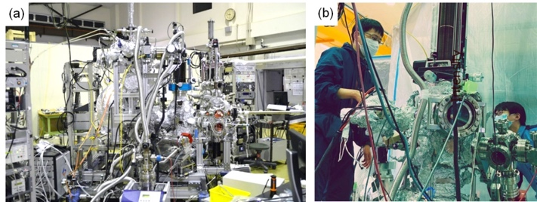

Fig. 2. (a) Laser-SARPES system and (b) ARTOF system at E-building.

