Neutron Science Laboratory

The Neutron Science Laboratory (NSL) has been playing a central role in neutron scattering activities in Japan since 1961 by performing its own research programs as well as providing a strong General User Program (GUP) for the university-owned various neutron scattering spectrometers installed at JRR-3 (20 MW) operated by Japan Atomic Energy Agency (JAEA) in Tokai, Ibaraki (Fig. 1).

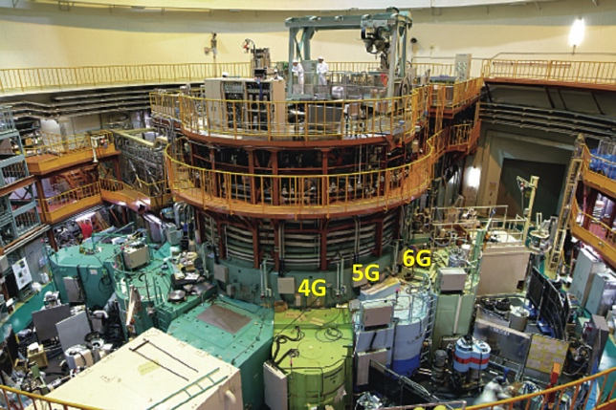

Fig. 1. Reactor hall of JRR-3. Three triple axis spectrometers are shown in the photo.

In 2003, the Neutron Scattering Laboratory was reorganized as the Neutron Science Laboratory to further promote the neutron science with use of the instruments in JRR-3. Under GUP supported by NSL, 12 university-group-owned spectrometers in the JRR-3 reactor are available for a wide scope of research on material science. The submitted proposals were about 300 and the visiting users reached over 6000 person-day in FY2010. In 2009, NSL and Neutron Science Division (KENS), High Energy Accelerator Research Organization (KEK) built a chopper spectrometer, High Resolution Chopper Spectrometer, HRC, at the beam line BL12 of MLF/J-PARC (Materials and Life Science Experimental Facility, J-PARC) (Fig. 2). HRC covers wide energy transfer (100 μeV < ħω < 0.5 eV) and momentum transfer (0.03 Å-1 < Q < 30 Å-1) ranges, and therefore becomes complementary to the existing inelastic spectrometers at JRR-3. HRC has accepted general users through the J-PARC proposal system since FY2011.

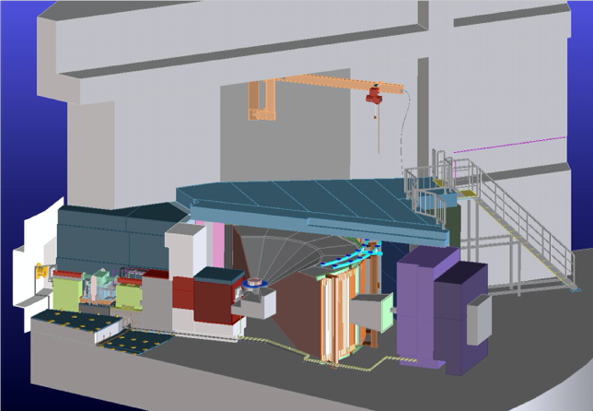

Fig. 2. Schematic view of HRC.
Triple axis spectrometers, HRC, a four-circle diffractometer, and a high resolution powder diffractometer are utilized mainly for a conventional solid state physics and a variety of research fields on hard-condensed matter, while in the field of soft-condensed matter science, researches are mostly carried out by using a small angle neutron scattering (SANS-U) and/or neutron spin echo (iNSE) instruments. The upgraded time-of-flight (TOF) inelastic scattering spectrometer, AGNES, is available both for hard- and soft-matter science. Our GUP has produced 2137 publications and 319 dissertations until April 23, 2024. Their lists for the last 10 years are given in Activity Report on Neutron Scattering Research which is available in ISSP and NSL web pages.

As for international cooperative programs, NSL operates the U.S.-Japan Cooperative Program on neutron scattering, providing further research opportunities to material scientists who utilize the neutron scattering technique for their research interests. In 2010, relocation of the U.S.-Japan triple-axis spectrometer, CTAX, was completed, and it is now open to Japanese users. In March 2024, we had an international review for the renewal of the cooperative program which is mandated by the MEXT every 10 years. The review and contract renewal were successfully completed and the cooperation program is now entering a new phase. Here, as proposed by the review committee, we plan to further revitalize soft matter science.

After the resumption of JRR-3 operation in 2021, many instrumental advances have been made. First, improvements to the instruments and guide tubes during the beam shutdown period (2011-2021) resulted in a 10-fold increase in the intensity of GPTAS (4G) and an 8-fold increase in AGNES (C3-1-1). Next, a new multiflex-type triple-axis spectrometer HODACA was constructed at C1-1. This spectrometer is 40 times more efficient than the conventional spectrometer (HER). The development and improvement of these instruments and the latest status of the other university spectrometers at JRR-3 are described in detail in a special topics of the Journal of the Physical Society of Japan (JPSJ) (Vol. 93(9)). Some improvements have also been made to the proposal adoption system: multibeam proposals (in cooperation with PF at KEK) were launched in 2022, student proposals (doctor-course students can apply as PIs) in 2023, international proposals (researchers from overseas institutions can apply as PIs) in 2024. Industrial proposals (in which researchers from industry can apply as PIs) are scheduled to begin in 2025.
We had conducted 84 experiments for 155 approved proposals in 2021 (reactor operation: 4 cycles, 92 days), 123 experiments for 166 approved proposals in 2022 (reactor operation: 7 cycles, 152 days), and 122 experiments for 154 approved proposals in 2023 (reactor operation: 6 cycles, 143 days). For these experiments, about 70 papers, including those under review, have been obtained as of May, 2024.

