**International MegaGauss**

**Science Laboratory**

The objective of this laboratory (Fig. 1) is to study the physical properties of solid-state materials (such as metals, semiconductors, insulators, superconductors, and magnetic materials) in a high magnetic field of 100 T or even higher. Such a high magnetic field can control material phases and functions. Our pulsed magnets, at the moment, can generate up to 88.6 Tesla (T) in a non-destructive manner and up to 1200 T in a destructive manner. The world record for an indoor magnetic field of 1200 T was achieved in 2018. The laboratory is open for scientists both domestic and overseas. Lots of fruitful results have come out from the collaborative researches and our in-house activities.

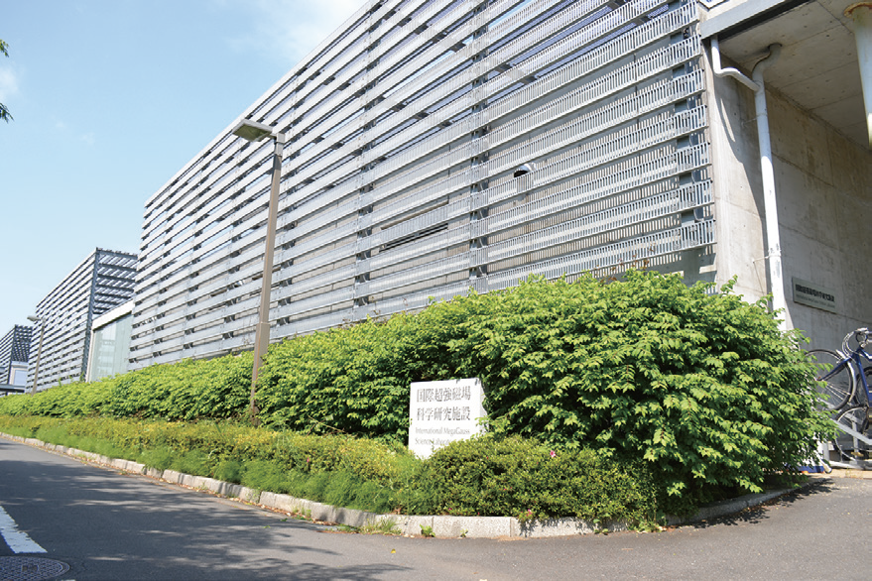

Fig. 1. The building C of the IMGSL.

Our interests cover the studies on quantum phase transitions (QPT) induced by high magnetic fields. Field-induced QPT has been explored in various materials, such as quantum spin systems, strongly correlated electron systems, and other magnetic materials. One of our ultimate goals is to provide joint-research users with a 100 T millisecond-long pulse using a non-destructive magnet and to offer versatile high-precision physical measurements. Measurable physical quantities or properties are magneto-optical spectra, magnetization, magnetostriction, electrical transport, specific heat, nuclear magnetic resonance, and ultrasound propagation. They can be carried out with sufficiently high accuracy. Another ultimate goal is to extend the magnetic field region and discover novel phenomena happening only in extremely strong magnetic fields exceeding 100 T. Recent technical developments allow us to even measure magnetostriction and ultrasound propagation in destructive magnetic fields over 100 T, which can directly reach potential structural changes in the ultrahigh magnetic fields. The recent discovery of magnetic field-induced insulator-metal transitions of strongly correlated materials in 500 T would open a new direction of the megagauss field research, namely the exploration of field-induced novel phases in materials with strong interactions comparable to the thermal energy at room temperature.

A set of supercapacitor power supplies with a total accumulation energy of 150 MJ (Fig. 2) was installed in 2023 and used as an energy source for super-long pulse magnets. The magnet technologies are intensively devoted to the quasi-steady long pulse magnet (an order of 1-10 sec) energized by the giant DC power supply. The giant DC power source will also be used for the giant outer magnet coil to realize a 100 T nondestructive magnet by inserting a conventional pulse magnet coil in its center bore. Recently, the super-long pulsed magnet has been intensively used to investigate thermal properties such as specific heat and magnetocaloric effects.

テキスト が含まれている画像

AI 生成コンテンツは誤りを含む可能性があります。

Fig. 2. Upper: The K-building for the supercapacitor power supply (left-hand side) and a long pulse magnet station (right-hand side). Lower: The supercapacitors have a total accumulation energy of 150 MJ installed in 2023 and are planned to drive the long pulse 60 T magnet and the first stage of the dual-coil 100 T non-destructive magnet.

Magnetic fields exceeding 100 T can only be obtained with the destruction of a magnet coil. The ultrahigh magnetic fields are obtained in a microsecond time scale. The project, financed by the Ministry of Education, Culture, Sports, Science and Technology aiming to generate 1000 T with the electromagnetic flux compression (EMFC) system (Fig. 3), has been completed.

屋内, キッチン, 金属, 男 が含まれている画像

AI 生成コンテンツは誤りを含む可能性があります。

Fig. 3. A view of the coil setup of the electromagnetic flux compression inside of an anti-explosive house. The world's strongest indoor magnetic field of 1200 T was achieved in 2018.

Our experimental techniques using the destructive magnetic fields have intensively been developed. The system, which is unique to ISSP on the world scale, is comprised of a power source of 5 MJ main condenser bank and 2 MJ condenser bank. Two magnet stations are constructed, and both are energized by each power source. Both systems are fed with another 2 MJ condenser bank used for a seed-field coil, the magnetic flux of which is to be compressed. The 2 MJ EMFC system can generate 450 T. The 5 MJ system is used for the generation of a 1000 T-class magnetic field. For the research in the magnetic field range of 100 - 300 T, we have two single-turn coil (STC) systems that have a fast-capacitor bank system of 200 kJ for each. One is the horizontal type (H-type), and the other is a vertical type (V-type, Fig. 4). Various kinds of laser spectroscopy experiments, such as the cyclotron resonance and the Faraday rotation, are possible using the H-type STC, while a stable low-temperature condition of 2 K is available for the V-type STC.

ダイアグラム

AI 生成コンテンツは誤りを含む可能性があります。

Fig. 4. Schematic picture of the V-type single-turn coil equipped with a 40 kV, 200 kJ fast capacitor bank system. The liquid-helium-bath cryostat with a plastic tail is also shown.

Available Magnets, Specifications

|  |  |  |  |  |  |  |  |
| --- | --- | --- | --- | --- | --- | --- | --- |
|  | Magnet | Type | Bmax | Pulse width  Bore | Power source | Applications | Others |
| Building C  Room  101-113 | Electromagnetic Flux Compression | Destructive | 1200 T | 3μs  (100–1200 T)  10 mm | 5 MJ, 50kV  2 MJ, 50kV | Magneto-Optics  Magnetization  Magneto-Striction  Magneto-Transport | 5 K - room temperature |
| Horizontal  Single-turn Coil | Destructive | 300 T  200 T | 6μs  5 mm  10 mm | 0.2 MJ, 50 kV | Magneto-Optics  Magnetization  Magneto-Striction  Magneto-Transport  Ultrasound | 5 K - room temperature |
| Vertical  Single-turn Coil | Destructive | 300 T  200 T | 8μs  5 mm  10 mm | 0.2 MJ, 40 kV | Magneto-Optics  Magnetization  Magneto-Striction  Magneto-Transport  Ultrasound | 2 K - room temperature |
| Building C  Room  114-120 | Mid-pulse Magnet | Non-destructive | 60 T  70 T | 40 ms  18 mm  40 ms  10 mm | 0.9 MJ, 10 kV | Magneto-Optics  Magnetization  Magneto-Transport  Electric-Polarization  Magneto-Striction  Magneto-Imaging  Torque  Magneto- Calorimetry  Heat Capacity  Ultrasound | Independent Experiment in 5 sites  Lowest temperature  0.1 K |
| Building C  Room 121 | PPMS | Steady | 14 T |  |  | Resistance  Heat Capacity | Down to 0.3 K |
| MPMS | Steady | 7 T |  |  | Magnetization | Down to 2 K |
| Building K | Short-pulse magnet | Non-destructive | 88.6 T | 2.5 ms  12 mm | 0.5 MJ, 20 kV | Magnetization  Magneto-Transport | 1.4 K - Room temperature |
| Long-pulse magnet | Non-destructive | 40 T | 1 s  30 mm | 150 MJ, 2.4 kV | Resistance  Magneto-Calorimetry | 0.5 K - Room temperature |