Laser and Synchrotron Research Center
(LASOR Center)

Laser and synchrotron research center (LASOR Center) was established in October 2012 to push the frontiers of the photon and materials science. LASOR has 10 groups in 2023, which is the largest division in ISSP. Most of the research activities on the development of new high-power lasers and their application to materials science are conducted in specially designed buildings D and E with large clean rooms and vibration-isolated floors at the Kashiwa campus. We also have a clean room for a laser processing platform at the Kashiwa II campus. On the other hand, experiments using synchrotron radiation are conducted at SPring-8 and SACLA (Hyogo). Recently, a new beamline has been developed at Nano Terasu in Sendai.

The development of new laser light sources in the vacuum ultraviolet to soft x-ray range has revolutionized materials research, represented by high energy resolution photoelectron spectroscopy, ultrafast time domain spectroscopy, and ultrafast nonlinear spectroscopy. Materials science research with lasers has entered a new era. The ultrashort and high-power lasers are becoming an increasingly attractive light source for both basic research and industry. The state-of-the-art laser source and spectroscopy are being intensively explored.

Synchrotron-based research is another area of activity at the ISSP. The dramatic increase in the brilliance of synchrotron radiation has also opened up a new field of photon science. In 2018, the Japanese government has announced the construction of a new synchrotron facility in Tohoku (Nano Terasu). LASOR has decided to subjectively contribute to this facility from design to operation, and Nano Terasu is now under construction.

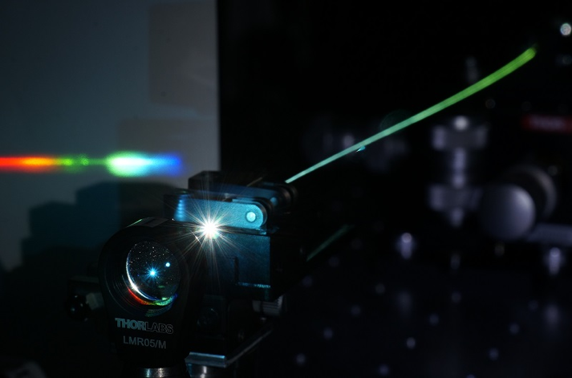

Fig. 1. Optical frequency comb

Lasers and synchrotrons have developed independently; today, both light sources cover a wide range of photon energies with an overlap in the vacuum-ultraviolet to soft X-ray regions. Recognizing their common interests in research areas and technologies, ISSP integrated the two streams, extreme lasers and synchrotron radiation, into a common platform. Through the mutual interactions between the frontiers of lasers and synchrotrons, LASOR will be the center of innovation in light and materials science through worldwide collaborative research and close cooperation with other divisions of ISSP such as New Materials Science, Nanoscale Science, and Condensed Matter Theory.

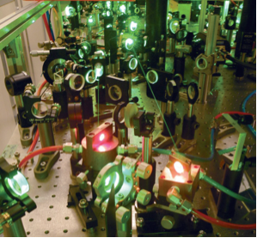
Fig. 2. Close look of a high-peak-power ultrashort-pulse laser

The mission of LASOR is to cultivate and advance the following three scientific fields:
- Laser Science,
- Synchrotron radiation science,
- Extreme Spectroscopy,

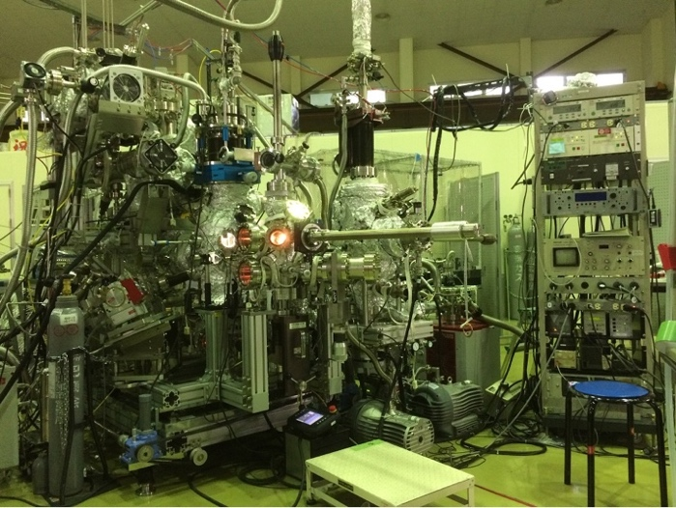

Fig. 3. Spin-resolved photo-emission spectroscopy.

Laser science group
We have continued to develop various state-of-the-art laser systems, such as high-power solid-state or gas lasers, high-intensity lasers, ultra-short pulse lasers down to the attosecond time scale (peta-Hz linewidth), ultra-stable 1-Hz linewidth lasers, optical frequency combs, mid-infrared lasers, THz light sources, and semiconductor lasers. The technology of high-power and ultrashort pulse lasers has progressed during these 10 years. It has opened two research directions. One is a coherent extreme ultraviolet light source realized by a high harmonic generation (HHG) scheme. The average power of HHG became high enough to be used for photoemission spectroscopy. Photon energies from 7 eV to 60 eV are now available. They can be either very narrow bandwidth or ultrashort pulse. The other is an industrial science such as laser processing. Variable pulse duration, 100 W average power, femtosecond laser is now available at LASOR for any collaborative research, including companies. We have a laser processing platform for both industrial and scientific applications.

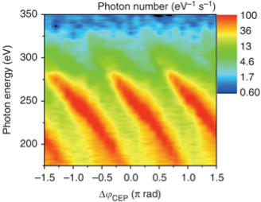

Fig. 4. Phase-dependence of high harmonic spectra in soft X rays.

We also aim to develop novel laser spectroscopy and coherent nonlinear optical physics enabled by emerging lasers and optical science/technology, and to comprehensively study fundamental light-matter physics, optical materials science, and applied photonics. Such research includes ultrafast spectroscopy for excited state dynamics, terahertz magnetic field spectroscopy for spin dynamics, quantitative microspectroscopy of semiconductor lasers, and nanostructured photonic devices such as quantum wire lasers, gain-switched semiconductor lasers, multi-junction solar cells, and bioluminescent systems.

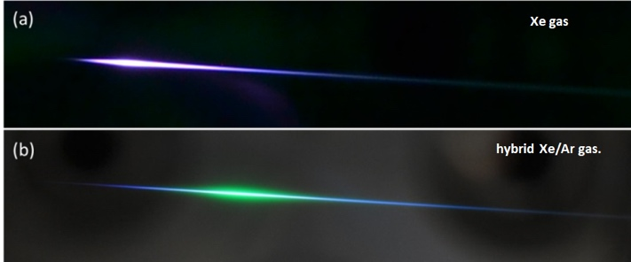

Fig. 5. Generation of 7-eV, femtosecond light with (a) Xe and (b) Xe/Ar gases.

Synchrotron radiation science group
By inheriting and developing the synchrotron techniques cultivated for more than 20 years, we are continuously developing world-class spectroscopies such as time-resolved photoemission/diffraction, ultra-high-resolution soft X-ray emission, 3D (depth + 2D microscopy) nano-ESCA, and X-ray magneto-optical effect, and providing these techniques for both basic materials science and applied science that contributes to the instrument applications in collaboration with outside researchers. In order to pioneer new spectroscopies for next-generation light sources, we are improving the fast polarization switching of the undulator light source in collaboration with SPring-8. In addition, we are promoting frontier work on the use of X-ray free-electron lasers, SACLA, with high spatial and temporal coherence comparable to optical lasers in collaboration with scientists of laser light sources and spectroscopy.

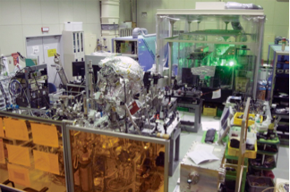

Fig. 6. Pump-probed photoemission system using 60-eV laser

Extreme spectroscopy group
The advent of laser-based light sources in the soft X-ray region opens a new stage in the field cultivated by synchrotron radiation. One of the milestones was the development of a laser-based light source of ~7 eV for sub-meV resolution photoemission spectroscopy. In the last five years, the available photon energy has been increased to 11 eV using Yb fiber laser technology. It has high photon flux(1014 photons/sec) with sub-picosecond time resolution. Laser-based spin-resolved ARPES is realized in LASOR with 11 eV laser. This technology would open up a whole new field of spectroscopy. High-harmonic-generation based photoemission spectroscopy in the 20-60 eV region is another direction to be pursued. Femtosecond time domain spectroscopy has been achieved. Combined with picosecond time-domain spectroscopy using the pulsed light delivered by synchrotrons, we are investigating the electronic structures and dynamics of matter in the bulk, on the surface, and down to the nanoscale. The ultimate goal is to extend soft x-ray operando methods to lasers. Diffractions, magneto-optical effects, and inelastic scattering now performed at synchrotrons will be performed by lasers to access the real-time dynamics of chemical reactions and phase transitions down to femtoseconds.

State-of-the-art laser-based organismal spectroscopy is a new direction in LASOR. The ISSP research field is shifting from simple materials and science to a complex one involving living bodies and functional materials with excited state physics.

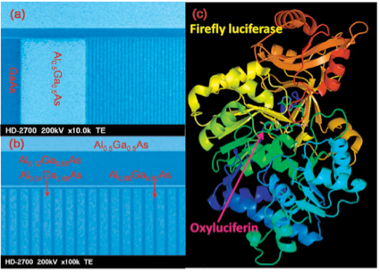

Fig. 7. Photonics devices under study: (left panel) semiconductor quantum wires and (right panel) firefly-bioluminescence system consisting of light emitter (oxyluciferin) and enzyme (luciferase)

