Center of Computational
Materials Science

With the advancement of hardware and software technologies, large-scale numerical calculations have been making important contributions to materials science and will have even greater impact on the field in the near future. CCMS is a specialized research center established in 2011 for promoting computer-aided materials science with massively parallel computers, such as the Fugaku supercomputer, which has been developed in Kobe as the core of a billiondollar national project. Activities of CCMS are divided into the following three categories: (1) highly efficient and largescale use of the Fugaku supercomputer and its application to grand-challenge problems in computational materials science, (2) activities as the center for the community of computational condensed matter physics and materials science, and (3) computational physics research aiming to solve intriguing physics emerged from strongly correlated systems.

For the first category, each group in CCMS is carrying out various individual research projects in its own expertise to efficiently utilize large-scale parallel computers. For example, the Ozaki group has been developing efficient and accurate methods and software packages to extend the applicability of DFT to more realistic systems, and investigated the structural and electronic properties of various 2D materials in successful collaboration with experimental groups and industrial companies. There are other activities such as development of Tensor Network (TN) based numerical methods and Markov-chain Monte Carlo methods by the Kawashima group and the Todo group.

As for the activities in the second category, apart from major annual conferences and formal international meetings, the CCMS provided a series of lectures and training sessions at Kashiwa. For example, training sessions "Kashiwa Hands On" for getting accustomed to various application programs, such as OpenMX, Hphi, mVMC, AkaiKKR, and MateriApps LIVE!, as shown in Fig. 1, have been held monthly. Each session is designed for more than 10 trainees and takes 4-5 hours. We also coordinate the use of the computational resources available to our community, and support community members through various activities such as administrating the website "MateriApps" for information on application software in computational science as shown in Fig. 2.

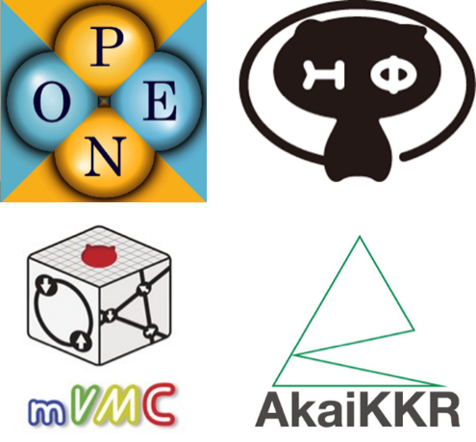

Fig. 1. Software in the CCMS community

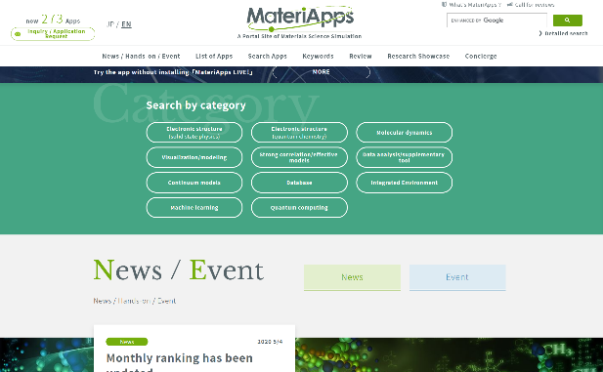

Fig. 2. MateriApps Website

For the third category, the Misawa group addressed searching for topological insulators in solids which is one of the main issues of modern condensed-matter physics since robust gapless edge or surface states of the topological insulators can be used as building blocks of next-generation devices, and showed a way to realize a topological state characterized by the quantized Zak phase, termed the Zak insulator with spin-polarized edges in organic antiferromagnetic Mott insulators without relying on the spin-orbit coupling. The finding provides an unprecedented way to realize a topological state in strongly correlated electron systems. Prof. Misawa was also involved in the Data generation and utilisation materials Research and development
projects (DxMT).

These activities are supported by funds for various
governmental projects including the DxMT project and the
Program for Promoting Researches on the Supercomputer
Fugaku.

The following is the selected list of meetings organized
by CCMS in recent years:
- 2023/3/29 DxMT workshop: recent progresses in machine-learning potentials.
- 2023/4/3-4 ISSP joint workshop for ISSP Supercomputer Co-use and CCMS.
- 2023/6/1 Matching Workshop for industries & graduate students/ postdocs.
- 2023/6/26 Symposium of the Division of Data-Integrated Materials Science, Social Cooperation Research Department at ISSP.
- 2023/12/19-20 MP-CoMS lecture series for OpenMX Workshop: Fundamentals and Practice.
- 2024/2/12-14 MaterialAI2023: utilization of AI technologies in computational materials science
- 2024/2/19-20 ISSP workshop for Integration of Materials Science Simulations and Advanced Experimental Data.

In addition to the events listed above, we organize
regular hands-on program for various application, such as
RESPACK and SALMON.

