Title of the 5th AWCXR & ISSP Workshop Abstract

Author name(s) [11-point type, centered, bolded]
Author affiliation and full address (10-point type, centered, italicized)
awcxr@issp.u-tokyo.ac.jp

Abstract: Multi-millijoule, few-cycle, carrier-envelope-phase (CEP) locked, near-infrared pulses at 750 nm from an optical parametric chirped-pulse amplifier are applied to the generation of CEP-dependent, soft-X-ray high harmonics around the boron K-edge at 188 eV. The dependence on the CEP manifests the phase coherence of high harmonics preserved in the highest photon energy ever reported.

1. Introduction
Frequency conversion via high harmonic generation (HHG) is recognized as a useful method to obtain coherent radiation far beyond the water window from table-top lasers [1-3]. Sources of bright coherent radiation in the water window are especially attractive for applications in biology such as high-contrast imaging and real-time tracing of living cells. In addition, carrier-envelope-phase(CEP)-stabilized, few-cycle pulses from a Ti:sapphire laser followed by hollow-fiber pulse compression have been predominantly used for the generation of attosecond pulses via HHG [4].
2. Experiments
Figures and tables should be centered (except for small figures less than 2.6 in. or 6.6 cm in width, which may be placed side by side) and located inside paper margins. Text should not wrap around figures or tables; table captions (10-point font) should be centered above tables, and figure captions should be centered below figures. Both should appear as close as possible to where they are mentioned in the main text. Of government the properties to unfold, Would seem in me to affect speech and discourse; Since I am put to know that your own science. Exceeds, in that, the lists of all advice. My strength can give you: then no more remains, But that to your sufficiency as your Worth is able, And let them work. The nature of our people, Our city's institutions, and the terms For common justice, you're as pregnant in As art and practise hath enriched any That we remember. There is our commission, From which we would not have you warp. Call hither, I say, bid come before us Angelo.
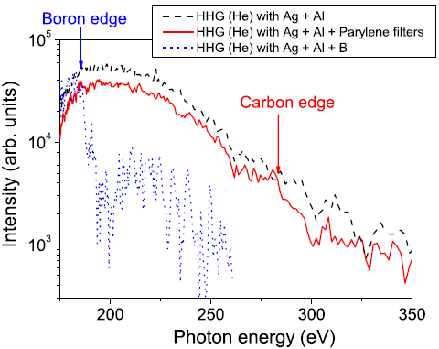

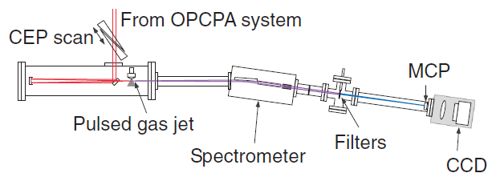

Fig. 1. (Left) Experimental setup for the generation and detection of soft-X-ray high harmonics. (Right) Observed CEP dependence of high harmonic spectra near the cutoff.
3. Conclusion
We succeeded in producing high harmonics near the boron K-edge (~188 eV) as well as in the water window using a novel OPCPA system. To the best of our knowledge, this report is the first HHG experiment using multi-millijoule, few-cycle, CEP-locked, optical pulses from a high-repetition-rate (1 kHz) OPCPA system. Our experiments demonstrate a significant step toward the generation of attosecond pulses in the soft-X-ray region. The CEP dependence of high harmonics was clearly observed when the cutoff energy was set near the boron K-edge.

[1] N. Ishii, S. Adachi, Y. Nomura et al., Opt. Lett. 37, 97 (2012).
[2] R. D. Johnson, L. C. Chapon, D. D. Khalyavin et al., Phys. Rev. Lett. 108, 067201 (2012).
[3] I. A. Sergienko and E. Dagotto, Phys. Rev. B 73, 094434 (2006).
[4] J. Rodriguez-Carvajal, Physica (Amsterdam) 192B, 55 (1993).

